Coordinate Systems
Locations in an image can be expressed in various coordinate systems, depending on context. This section discusses the two main coordinate systems used in the Image Processing Toolbox and the relationship between them. These two coordinate systems are described in
- Pixel Coordinates
- Spatial Coordinates
- Using a Nondefault Spatial Coordinate System

Pixel Coordinates
Generally, the most convenient method for expressing locations in an image is to use pixel coordinates. In this coordinate system, the image is treated as a grid of discrete elements, ordered from top to bottom and left to right, as illustrated by the following figure.

The Pixel Coordinate System
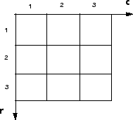
For pixel coordinates, the first component r (the row) increases downward, while the second component c (the column) increases to the right. Pixel coordinates are integer values and range between 1 and the length of the row or column.
There is a one-to-one correspondence between pixel coordinates and the coordinates MATLAB uses for matrix subscripting. This correspondence makes the relationship between an image's data matrix and the way the image is displayed easy to understand. For example, the data for the pixel in the fifth row, second column is stored in the matrix element (5,2). You use normal MATLAB matrix subscripting to access values of individual pixels. For example, the MATLAB code
I(2,15)
returns the value of the pixel at row 2, column 15 of the image I.

Spatial Coordinates
In the pixel coordinate system, a pixel is treated as a discrete unit, uniquely identified by a single coordinate pair, such as (5,2). From this perspective, a location such as (5.3,2.2) is not meaningful.
At times, however, it is useful to think of a pixel as a square patch. From this perspective, a location such as (5.3,2.2) is meaningful, and is distinct from (5,2). In this spatial coordinate system, locations in an image are positions on a plane, and they are described in terms of x and y (not r and c as in the pixel coordinate system).
The following figure illustrates the spatial coordinate system used for images. Notice that y increases downward.

The Spatial Coordinate System
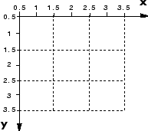
This spatial coordinate system corresponds closely to the pixel coordinate system in many ways. For example, the spatial coordinates of the center point of any pixel are identical to the pixel coordinates for that pixel.
There are some important differences, however. In pixel coordinates, the upper left corner of an image is (1,1), while in spatial coordinates, this location by default is (0.5,0.5). This difference is due to the pixel coordinate system's being discrete, while the spatial coordinate system is continuous. Also, the upper left corner is always (1,1) in pixel coordinates, but you can specify a nondefault origin for the spatial coordinate system. See Using a Nondefault Spatial Coordinate System for more information.
Another potentially confusing difference is largely a matter of convention: the order of the horizontal and vertical components is reversed in the notation for these two systems. As mentioned earlier, pixel coordinates are expressed as (r,c), while spatial coordinates are expressed as (x,y). In the reference pages, when the syntax for a function uses r and c, it refers to the pixel coordinate system. When the syntax uses x and y, it refers to the spatial coordinate system.

Using a Nondefault Spatial Coordinate System
By default, the spatial coordinates of an image correspond with the pixel coordinates. For example, the center point of the pixel in row 5, column 3 has spatial coordinates x=3, y=5. (Remember, the order of the coordinates is reversed.) This correspondence simplifies many of the toolbox functions considerably. Several functions primarily work with spatial coordinates rather than pixel coordinates, but as long as you are using the default spatial coordinate system, you can specify locations in pixel coordinates.
In some situations, however, you might want to use a nondefault spatial coordinate system. For example, you could specify that the upper left corner of an image is the point (19.0,7.5), rather than (0.5,0.5). If you call a function that returns coordinates for this image, the coordinates returned will be values in this nondefault spatial coordinate system.
To establish a nondefault spatial coordinate system, you can specify the XData and YData image properties when you display the image. These properties are two-element vectors that control the range of coordinates spanned by the image. By default, for an image A, XData is [1 size(A,2)], and YData is [1 size(A,1)].
For example, if A is a 100 row by 200 column image, the default XData is [1 200], and the default YData is [1 100]. The values in these vectors are actually the coordinates for the center points of the first and last pixels (not the pixel edges), so the actual coordinate range spanned is slightly larger; for instance, if XData is [1 200], the x-axis range spanned by the image is [0.5 200.5].
These commands display an image using nondefault XData and YData.
A = magic(5);
x = [19.5 23.5];
y = [8.0 12.0];
image(A,'XData',x,'YData',y), axis image, colormap(jet(25))
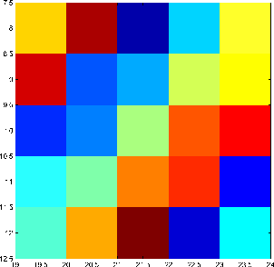
For information about the syntax variations that specify nondefault spatial coordinates, see the reference page for imshow.

Image Types in the Toolbox
The Image Processing Toolbox defines four basic types of images, summarized in the following table. These image types determine the way MATLAB interprets data matrix elements as pixel intensity values. The sections that follow provide more information about each image type. See also Converting Between Image Types.
Image Type | Interpretation
Binary | Logical array containing only 0s and 1s, interpreted as black and white, respectively. Also known as a bilevel image.
Indexed | Array of class logical, uint8, uint16, single, or double whose pixel values are direct indices into a colormap. The colormap is an m-by-3 array of class double. Also known as a pseudocolor image.
  Note For single or double arrays, integer values range from [1, p]. For logical, uint8, or uint16 arrays, values range from [0, p-1]
Grayscale | Array of class uint8, uint16, int16, single, or double whose pixel values specify intensity values. Also known as an intensity image
  Note For single or double arrays, values range from [0, 1]. For uint8, values range from [0,255]. For uint16, values range from [0, 65535]. For int16, values range from [-32768, 32767].
Truecolor | m-by-n-by-3 array of class uint8, uint16, single, or double whose pixel values specify intensity values. Also known as an RGB image.
  Note For single or double arrays, values range from [0, 1]. For uint8, values range from [0, 255]. For uint16, values range from [0, 65535].

Binary Images
In a binary image, each pixel assumes one of only two discrete values: 1 or 0. A binary image is stored as a logical array. By convention, this documentation uses the variable name BW to refer to binary images.
The following figure shows a binary image with a close-up view of some of the pixel values.

Pixel Values in a Binary Image
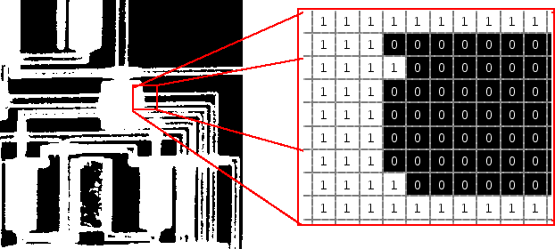

Image Processing Toolbox

Indexed Images
An indexed image consists of an array and a colormap matrix. The pixel values in the array are direct indices into a colormap. By convention, this documentation uses the variable name X to refer to the array and map to refer to the colormap.
The colormap matrix is an m-by-3 array of class double containing floating-point values in the range [0,1]. Each row of map specifies the red, green, and blue components of a single color. An indexed image uses direct mapping of pixel values to colormap values. The color of each image pixel is determined by using the corresponding value of X as an index into map.
A colormap is often stored with an indexed image and is automatically loaded with the image when you use the imread function. After you read the image and the colormap into the MATLAB workspace as separate variables, you must keep track of the association between the image and colormap. However, you are not limited to using the default colormap--you can use any colormap that you choose.
The relationship between the values in the image matrix and the colormap depends on the class of the image matrix. If the image matrix is of class single or double, it normally contains integer values 1 through p, where p is the length of the colormap. the value 1 points to the first row in the colormap, the value 2 points to the second row, and so on. If the image matrix is of class logical, uint8 or uint16, the value 0 points to the first row in the colormap, the value 1 points to the second row, and so on.
The following figure illustrates the structure of an indexed image. In the figure, the image matrix is of class double, so the value 5 points to the fifth row of the colormap.

Pixel Values Index to Colormap Entries in Indexed Images
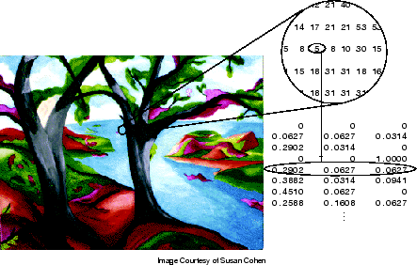

Grayscale Images
A grayscale image is a data matrix whose values represent intensities within some range. MATLAB stores a grayscale image as a individual matrix, with each element of the matrix corresponding to one image pixel. By convention, this documentation uses the variable name I to refer to grayscale images.
The matrix can be of class uint8, uint16, int16, single, or double.While grayscale images are rarely saved with a colormap, MATLAB uses a colormap to display them.
For a matrix of class single or double, using the default grayscale colormap, the intensity 0 represents black and the intensity 1 represents white. For a matrix of type uint8, uint16, or int16, the intensity intmin(class(I)) represents black and the intensity intmax(class(I)) represents white.
The figure below depicts a grayscale image of class double.

Pixel Values in a Grayscale Image Define Gray Levels
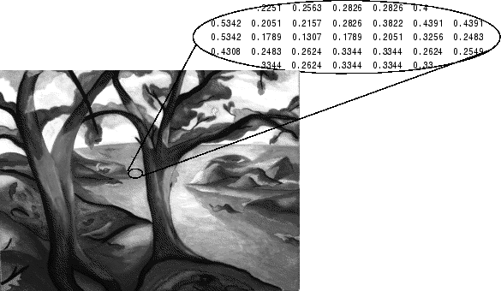

Truecolor Images
A truecolor image is an image in which each pixel is specified by three values — one each for the red, blue, and green components of the pixel's color. MATLAB store truecolor images as an m-by-n-by-3 data array that defines red, green, and blue color components for each individual pixel. Truecolor images do not use a colormap. The color of each pixel is determined by the combination of the red, green, and blue intensities stored in each color plane at the pixel's location.
Graphics file formats store truecolor images as 24-bit images, where the red, green, and blue components are 8 bits each. This yields a potential of 16 million colors. The precision with which a real-life image can be replicated has led to the commonly used term truecolor image.
A truecolor array can be of class uint8, uint16, single, or double. In a truecolor array of class single or double, each color component is a value between 0 and 1. A pixel whose color components are (0,0,0) is displayed as black, and a pixel whose color components are (1,1,1) is displayed as white. The three color components for each pixel are stored along the third dimension of the data array. For example, the red, green, and blue color components of the pixel (10,5) are stored in RGB(10,5,1), RGB(10,5,2), and RGB(10,5,3), respectively.
The following figure depicts a truecolor image of class double.

The Color Planes of a Truecolor Image
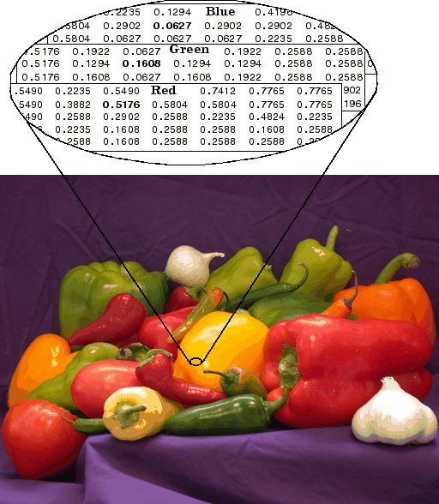
To determine the color of the pixel at (2,3), you would look at the RGB triplet stored in (2,3,1:3). Suppose (2,3,1) contains the value 0.5176, (2,3,2) contains 0.1608, and (2,3,3) contains 0.0627. The color for the pixel at (2,3) is
0.5176 0.1608 0.0627
To further illustrate the concept of the three separate color planes used in a truecolor image, the code sample below creates a simple image containing uninterrupted areas of red, green, and blue, and then creates one image for each of its separate color planes (red, green, and blue). The example displays each color plane image separately, and also displays the original image.
RGB=reshape(ones(64,1)*reshape(jet(64),1,192),[64,64,3]);
R=RGB(:,:,1);
G=RGB(:,:,2);
B=RGB(:,:,3);
imshow(R)
figure, imshow(G)
figure, imshow(B)
figure, imshow(RGB)

The Separated Color Planes of an RGB Image
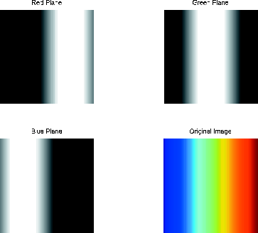
Notice that each separated color plane in the figure contains an area of white. The white corresponds to the highest values (purest shades) of each separate color. For example, in the Red Plane image, the white represents the highest concentration of pure red values. As red becomes mixed with green or blue, gray pixels appear. The black region in the image shows pixel values that contain no red values, i.e., R == 0.

Converting Between Image Types
You might need to convert an image from one type to another. For example, if you want to filter a color image that is stored as an indexed image, you must first convert it to truecolor format. When you apply the filter to the truecolor image, MATLAB filters the intensity values in the image, as is appropriate. If you attempt to filter the indexed image, MATLAB simply applies the filter to the indices in the indexed image matrix, and the results might not be meaningful.
Note When you convert an image from one format to another, the resulting image might look different from the original. For example, if you convert a color indexed image to a grayscale image, the resulting image is grayscale, not color.
The following table lists all the image type conversion functions in the Image Processing Toolbox.
Function | Description
dither | Use dithering to convert a grayscale image to a binary image or to convert a truecolor image to an indexed image
gray2ind | Convert a grayscale image to an indexed image
grayslice | Convert a grayscale image to an indexed image by using multilevel thresholding
im2bw | Convert a grayscale image, indexed image, or truecolor image, to a binary image, based on a luminance threshold
ind2gray | Convert an indexed image to a grayscale image
ind2rgb | Convert an indexed image to a truecolor image
mat2gray | Convert a data matrix to a grayscale image, by scaling the data
rgb2gray | Convert a truecolor image to a grayscale image
rgb2ind | Convert a truecolor image to an indexed image
You can perform certain conversions just using MATLAB syntax. For example, you can convert a grayscale image to truecolor format by concatenating three copies of the original matrix along the third dimension.
RGB = cat(3,I,I,I);
The resulting truecolor image has identical matrices for the red, green, and blue planes, so the image displays as shades of gray.
In addition to these standard conversion functions, there are other functions that return a different image type as part of the operation they perform. For example, the region-of-interest functions return a binary image that you can use to mask an image for filtering or for other operations.

Color Space Conversions
The Image Processing Toolbox represents colors as RGB values in both truecolor and indexed images. However, there are other methods for representing colors. For example, a color can be represented by its hue, saturation, and value components (HSV). Different methods for representing colors are called color spaces.
The toolbox provides functions to convert between color spaces. The image processing functions themselves assume all color data is RGB, but you can process an image that uses a different color space by first converting it to RGB, and then converting the processed image back to the original color space. For more information about color space conversion routines, see Color.

Image Arithmetic
Image arithmetic is the implementation of standard arithmetic operations, such as addition, subtraction, multiplication, and division, on images. Image arithmetic has many uses in image processing both as a preliminary step in more complex operations and by itself. For example, image subtraction can be used to detect differences between two or more images of the same scene or object.
You can do image arithmetic using the MATLAB arithmetic operators. The Image Processing Toolbox also includes a set of functions that implement arithmetic operations for all numeric, nonsparse data types. The toolbox arithmetic functions accept any numeric data type, including uint8, uint16, and double, and return the result image in the same format. The functions perform the operations in double precision, on an element-by-element basis, but do not convert images to double-precision values in the MATLAB workspace. Overflow is handled automatically. The functions saturate return values to fit the data type. For details, see Image Arithmetic Saturation Rules.
Note On Intel architecture processors, the image arithmetic functions can take advantage of the Intel Performance Primitives Library (IPPL), thus accelerating their execution time. IPPL is only activated, however, when the data passed to these functions is of specific classes. See the reference pages for the individual arithmetic functions for more information.

Image Arithmetic Saturation Rules
The results of integer arithmetic can easily overflow the data type allotted for storage. For example, the maximum value you can store in uint8 data is 255. Arithmetic operations can also result in fractional values, which cannot be represented using integer arrays.
MATLAB arithmetic operators and the Image Processing Toolbox arithmetic functions use these rules for integer arithmetic:
- Values that exceed the range of the integer type are saturated to that range.
- Fractional values are rounded.
For example, if the data type is uint8, results greater than 255 (including Inf) are set to 255. The following table lists some additional examples.
Result | Class | Truncated Value
300 | uint8 | 255
-45 | uint8 | 0
10.5 | uint8 | 11

Nesting Calls to Image Arithmetic Functions
You can use the image arithmetic functions in combination to perform a series of operations. For example, to calculate the average of two images,
You could enter
I = imread('rice.png');
I2 = imread('cameraman.tif');
K = imdivide(imadd(I,I2), 2); % not recommended
When used with uint8 or uint16 data, each arithmetic function rounds and saturates its result before passing it on to the next operation. This can significantly reduce the precision of the calculation. A better way to perform this calculation is to use the imlincomb function. imlincomb performs all the arithmetic operations in the linear combination in double precision and only rounds and saturates the final result.
K = imlincomb(.5,I,.5,I2); % recommended

Getting Information About a Graphics File
The imfinfo function enables you to obtain information about a graphics file and its contents. You can use imfinfo with any of the formats supported by MATLAB. Use the imformats function to determine which formats are supported.
Note You can also get information interactively about an image displayed in the Image Tool — see Getting Information About an Image.
The information returned by imfinfo depends on the file format, but it always includes at least the following:
- Name of the file
- File format
- Version number of the file format
- File modification date
- File size in bytes
- Image width in pixels
- Image height in pixels
- Number of bits per pixel
- Image type: truecolor (RGB), grayscale (intensity), or indexed
See imfinfo for more information about getting information about graphics files. For information about adding support for a new file format, see imformats

Reading Image Data
The imread function reads an image from any supported graphics image file format, in any of the supported bit depths. Most image file formats use 8 bits to store pixel values. When these are read into memory, MATLAB stores them as class uint8. For file formats that support 16-bit data, PNG and TIFF, MATLAB stores the images as class uint16.
For example, this code reads a truecolor image into the MATLAB workspace as the variable RGB.
RGB = imread('football.jpg');
This code reads an indexed image with its associated colormap into the MATLAB workspace in two separate variables.
[X,map] = imread('trees.tif');
Note For indexed images, imread always reads the colormap into a matrix of class double, even though the image array itself may be of class uint8 or uint16.
In these examples, imread infers the file format to use from the contents of the file. You can also specify the file format as an argument to imread. MATLAB supports many common graphics file formats, such as Microsoft Windows Bitmap (BMP), Graphics Interchange Format (GIF), Joint Photographic Experts Group (JPEG), Portable Network Graphics (PNG), and Tagged Image File Format (TIFF) formats. For the latest information concerning the bit depths and/or image formats supported, see the reference pages for the imread and imformats functions.

Reading Multiple Images from a Graphics File
MATLAB supports several graphics file formats, such as HDF and TIFF, that can contain multiple images. By default, imread imports only the first image from a file. To import additional images from the file, use the syntax supported by the file format.
For example, when used with TIFF files, you can use an index value with imread that identifies the image in the file you want to import. This example reads a series of 27 images from a TIFF file and stores the images in a four-dimensional array. You can use imfinfo to determine how many images are stored in the file.
mri = uint8(zeros(128,128,1,27)); % preallocate 4-D array

for frame=1:27
[mri(:,:,:,frame),map] = imread('mri.tif',frame);
end
When a file contains multiple images that are related in some way, such as a time sequence, you can store the images in MATLAB as a 4-D array. All the images must be the same size. For more information, see Working with Image Sequences.

Measuring Features in an Image
This section describes how to use the Distance tool to calculate the Euclidean distance between two points in an image displayed in the Image Tool. Topics covered include:
- Using the Distance Tool
- Exporting Endpoint and Distance Data
- Customizing the Appearance of the Distance Tool

Using the Distance Tool
To use the Distance tool, follow this procedure.
- Display an image in the Image Tool.
imtool('moon.tif')
- Click the Distance tool button in the Image Tool toolbar or select Distance Tool from the Tools menu. The Distance tool appears as a horizontal line displayed over the image, as shown in the following figure.
The Distance tool displays the distance between the two endpoints of the line in a label superimposed over the line. The tools specifies the distance in data units determined by the XData and YData properties, which is pixels, by default.
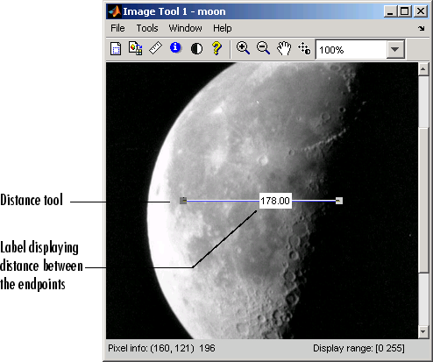
- Using the mouse, you can move the Distance tool over the image or, by grabbing either one of its endpoints, resize the tool.

Exporting Endpoint and Distance Data
To save the endpoint locations and distance information, right-click the Distance tool and choose the Copy pixel info option from the context menu.
The Distance tool opens the Export to Workspace dialog box. You can use this dialog box to specify the names of the variables used to store this information.
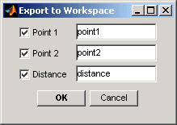
After you click OK, the Distance tool creates the variables in the workspace, as in the following example.
whos
Name Size Bytes Class

distance 1x1 8 double array
moon 537x358 192246 uint8 array
point1 1x2 16 double array
point2 1x2 16 double array

Customizing the Appearance of the Distance Tool
Using the Distance tool context menu, you can customize many aspects of the Distance tool appearance and behavior, including:
- Toggling the distance tool label on and off using the Show Distance Label option.
- Changing the color used to display the Distance tool line using the Set line color option.
- Constraining movement of the tool to either horizontal or vertical using the Constrain drag option.
- Deleting the distance tool object using the Delete option.
Right-click the Distance tool to access this context menu.

Interpolation
Interpolation is the process used to estimate an image value at a location in between image pixels. For example, if you resize an image so it contains more pixels than it did originally, the toolbox uses interpolation to determine the values for the additional pixels. The imresize and imrotate geometric functions use two-dimensional interpolation as part of the operations they perform. The improfile image analysis function also uses interpolation. See Getting the Intensity Profile of an Image for information about this function.

Interpolation Methods
The Image Processing Toolbox provides three interpolation methods:
- Nearest-neighbor interpolation
- Bilinear interpolation
- Bicubic interpolation
The interpolation methods all work in a fundamentally similar way. In each case, to determine the value for an interpolated pixel, they find the point in the input image that the output pixel corresponds to. They then assign a value to the output pixel by computing a weighted average of some set of pixels in the vicinity of the point. The weightings are based on the distance each pixel is from the point.
The methods differ in the set of pixels that are considered:
- For nearest-neighbor interpolation, the output pixel is assigned the value of the pixel that the point falls within. No other pixels are considered.
- For bilinear interpolation, the output pixel value is a weighted average of pixels in the nearest 2-by-2 neighborhood.
- For bicubic interpolation, the output pixel value is a weighted average of pixels in the nearest 4-by-4 neighborhood.
The number of pixels considered affects the complexity of the computation. Therefore the bilinear method takes longer than nearest-neighbor interpolation, and the bicubic method takes longer than bilinear. However, the greater the number of pixels considered, the more accurate the effect is, so there is a tradeoff between processing time and quality.

Interpolation and Image Types
You can use all three types of interpolation with grayscale, truecolor, or binary images; however, bilinear or bicubic are recommended. Nearest-neighbor is the only type of interpolation that can be used with indexed images.

Resizing an Image
To change the size of an image, use the imresize function. Using imresize, you can
- Specify the size of the output image
- Specify the interpolation method used
- Specify the filter to use to prevent aliasing

Specifying the Size of the Output Image
Using imresize, you can specify the size of the output image in two ways:
- By specifying the magnification factor to be used on the image
- By specifying the dimensions of the output image

Using the Magnification Factor
To enlarge an image, specify a magnification factor greater than 1. To reduce an image, specify a magnification factor between 0 and 1. For example, the command below increases the size of an image by 1.25 times.
I = imread('circuit.tif');
J = imresize(I,1.25);
imshow(I)
figure, imshow(J)
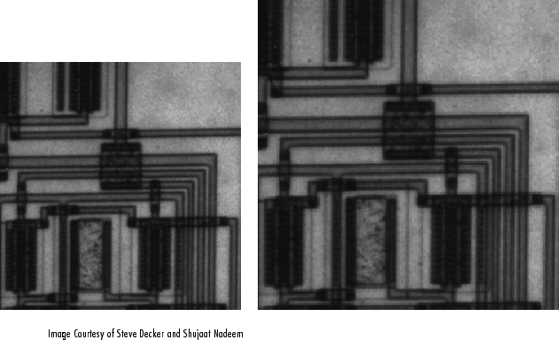

Specifying the Size of the Output Image
You can specify the size of the output image by passing a vector that contains the number of rows and columns in the output image. If the specified size does not produce the same aspect ratio as the input image, the output image will be distorted.
The following command creates an output image with 100 rows and 150 columns.
I = imread('circuit.tif');
J = imresize(I,[100 150]);
imshow(I)
figure, imshow(J)

Specifying the Interpolation Method
By default, imresize uses nearest-neighbor interpolation to determine the values of pixels in the output image, but you can specify other interpolation methods. This table lists the supported interpolation methods in order of complexity. See Interpolation for more information about these methods.
Argument Value | Interpolation Method
'nearest' | Nearest-neighbor interpolation (the default)
'bilinear' | Bilinear interpolation
'bicubic' | Bicubic interpolation
In this example, imresize uses the bilinear interpolation method.
Y = imresize(X,[100 150],'bilinear')

Using Filters to Prevent Aliasing
When you reduce the size of an image, you lose some of the original pixels because there are fewer pixels in the output image. Aliasing that occurs as a result of size reduction normally appears as "stair-step" patterns (especially in high-contrast images), or as moiré (ripple-effect) patterns in the output image.
When you specify either bilinear or bicubic as the interpolation method, imresize automatically applies a lowpass filter to the image before interpolation to limit the impact of aliasing on the output image.
Note Even with lowpass filtering, resizing an image can introduce artifacts, because information is always lost when you reduce the size of an image.
The imresize function does not apply a lowpass filter if nearest-neighbor interpolation is used. Nearest-neighbor interpolation is primarily used for indexed images, and lowpass filtering is not appropriate for these images.
When using imresize to reduce the size of an image, you can specify the size of the lowpass filter or specify a filter of your own creation. For example, the following code specifies a 9-by-9 filter. (The default size is 11-by-11.) If you specify the value 0 (zero), imresize does not perform lowpass filtering.
J = imresize(I,'bilinear',9);
For more information about specifying a filter, see the reference page for imresize.

Rotating an Image
To rotate an image, use the imrotate function. imrotate accepts two primary arguments:
- The image to be rotated
- The rotation angle
You specify the rotation angle in degrees. If you specify a positive value, imrotate rotates the image counterclockwise; if you specify a negative value, imrotate rotates the image clockwise. This example rotates the image I 35 degrees in the counterclockwise direction.
J = imrotate(I,35);
As optional arguments to imrotate, you can also specify
- The size of the output image
- The interpolation method

Specifying the Size of the Output Image
By default, imrotate creates an output image large enough to include the entire original image. Pixels that fall outside the boundaries of the original image are set to 0 and appear as a black background in the output image. If you specify the text string `crop' as an argument, imrotate crops the output image to be the same size as the input image. (See the reference page for imrotate for an example of cropping.)

Specifying the Interpolation Method
By default, imrotate uses nearest-neighbor interpolation to determine the value of pixels in the output image, but you can specify other interpolation methods. This table lists the supported interpolation methods in order of complexity. See Interpolation for more information about these methods.
Argument Value | Interpolation Method
'nearest' | Nearest-neighbor interpolation (the default)
'bilinear' | Bilinear interpolation
'bicubic' | Bicubic interpolation
For example, these commands rotate an image 35° counterclockwise and use bilinear interpolation.
I = imread('circuit.tif');
J = imrotate(I,35,'bilinear');
imshow(I)
figure, imshow(J)
